Abstract submission guidelines

A. Author^{1*}, B. Author¹ and C. Author²

¹Research Centre, Engineering Dpt., Faculty of Engineering University of Porto, Porto, Portugal;
²Institute, Lisboa, Portugal
*corresponding.author@emailaddress.com
Keywords: Author can use additional keywords using natural language.
Keywords must be separated by commas.
This is a template for the preparation of the abstracts to be submitted to the 2nd Doctoral Congress in Engineering – Symposium on Chemical, Biological and Environmental Engineering. Formatting of text sizes and fonts (Calibri 11 for this main body of the abstract), margins, spacing, paragraphs, page, etc. have been chosen in order to normalize the final contents of the book of abstracts. Therefore, we would thank that the authors prepare the manuscript following this structure, without changing any format parameter.

Title format for the different sections
The use of different sections is not mandatory, but if they are going to be used, the corresponding title should follow the format indicated in this example, with the title in Calibri 12 bold. Please note that the spacing before the section title is of 12 points, and after the section title is of 8 points. This spacing of 8 points is the same for the spacing after any paragraph of the abstract.

Extension of the abstract
The abstract should have a maximum extension of 2 pages. There is no minimum extension, but take into account that the acceptation of the communication will be based on the evaluation of the submitted abstract.
Any submitted abstract with an extension longer than 2 pages or with a different format disrespecting the rules of this template will be not admitted, and will be automatically rejected.

Tables and figures
The use of tables within the text should be in a separate line. Each table should be numbered in the caption. The table text should be set to 10 points font size, with the headings in bold.
Table 1. Table caption exemple.
Flexural Strength  (psi) | Electric Conductivity  (S/cm) | Specific Weight  (g/cm3)
>1730 | 80 | 1,27
<1200 | 50 | 0,65

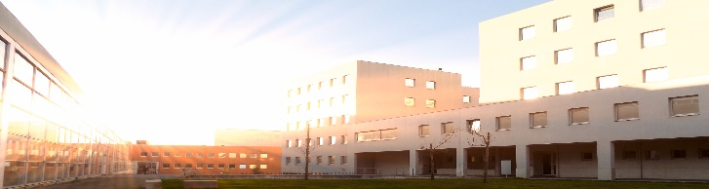
Figures must be numbered and its caption should be placed bellow the image and set to a font size of 10 points. Authors are responsible for the quality of the figures inserted but we strongly advise to use images that have quality enough for printing purposes (at least 300 dpi). Please avoid the use of shading and be reasonable with the size of text and width of lines, the figure must be clearly legible, thus contrast should be as pronounced as possible.
Figure 1. Figure caption example.

Authors are responsible for obtaining permission to reproduce copyrighted material from other sources. As an author, you are required to secure permission if you want to reproduce any figure, table or extract from the text of another source.
Caption for Tables and Figures should be positioned below the corresponding item and include the text “Table x.”, “Figure x.” in bold formatted at Calibri 10.

Formulas
The use of formulas within the text should be in a separate line and centred. Displayed expressions must be numbered in the caption, which should be set in the same line as the formula, enclosed in parentheses and right margined.
$a^{2}+3y=z$ (1)

In-text citations
When citing authors should use the author-date system, which means including in the text and between curved brackets, the last name of the authors and the date (ex. Smith 2005). The complete reference should be listed at the end of the document using the Chicago Manual of Style. Instructions and examples of references can be found at http://www.chicagomanualofstyle.org. Authors can use tools like EndNote or Mendeley to support this process.

References
Cardoso, Henrique Daniel de Avelar Lopes and Eugénio da Costa Oliveira. 2005. "Virtual enterprise normative framework within electronic institutions". In Engineering Societies in the Agents World V, 14-32. Heidelberg: Springer.
IEEE (Institute of Electrical and Electronics Engineers). 2012. “IEEE Advancing Technology for Humanity”. Accessed 28 August, 2014. http://www.ieee.org/index.html.
Gunerhan, H., A. Hepbasli and U. Giresunlu. 2009. "Environmental impacts from the solar energy systems". Energy Sources, Part A: Recovery, Utilization and Environmental Effects 31 (2):131-138. Accessed 28 August, 2014. doi: 10.1080/15567030701512733.

