Abstract submission guidelines

A. Author^{1*}, B. Author¹ and C. Author²

¹Research Centre, Engineering Dpt., Faculty of Engineering University of Porto, Porto, Portugal;
²Institute, Lisboa, Portugal
*corresponding.author@emailaddress.com
Keywords: Author can use additional keywords using natural language.
Keywords must be separated by commas.
This is a template for the preparation of the abstracts to be submitted to the 2nd Doctoral Congress in Engineering – Symposium on Refining, Petrochemical and Chemical Engineering. Formatting of text sizes and fonts (Calibri 11 for this main body of the abstract), margins, spacing, paragraphs, page, etc. have been chosen in order to normalize the final contents of the book of abstracts. Therefore, we would thank that the authors prepare the manuscript following this structure, without changing any format parameter.

Title format for the different sections
The use of different sections is not mandatory, but if they are going to be used, the corresponding title should follow the format indicated in this example, with the title in Calibri 12 bold. Please note that the spacing before the section title is of 12 points, and after the section title is of 8 points. This spacing of 8 points is the same for the spacing after any paragraph of the abstract.

Extension of the abstract
The abstract should have a maximum extension of 2 pages. There is no minimum extension, but take into account that the acceptation of the communication will be based on the evaluation of the submitted abstract.
Any submitted abstract with an extension longer than 2 pages or with a different format disrespecting the rules of this template will be not admitted, and will be automatically rejected.

Tables and figures
The use of tables within the text should be in a separate line. Each table should be numbered in the caption. The table text should be set to 10 points font size, with the headings in bold.
Table 1. Table caption exemple.
Flexural Strength  (psi) | Electric Conductivity  (S/cm) | Specific Weight  (g/cm3)
>1730 | 80 | 1,27
<1200 | 50 | 0,65
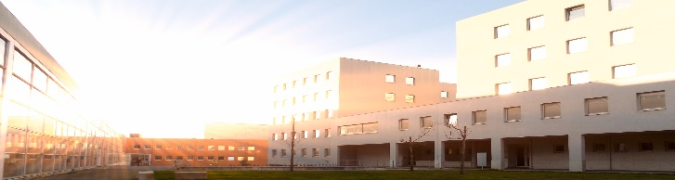
Figures must be numbered and its caption should be placed bellow the image and set to a font size of 10 points. Authors are responsible for the quality of the figures inserted but we strongly advise to use images that have quality enough for printing purposes (at least 300 dpi). Please avoid the use of shading and be reasonable with the size of text and width of lines, the figure must be clearly legible, thus contrast should be as pronounced as possible.
Figure 1. Figure caption example.

Authors are responsible for obtaining permission to reproduce copyrighted material from other sources. As an author, you are required to secure permission if you want to reproduce any figure, table or extract from the text of another source.
Caption for Tables and Figures should be positioned below the corresponding item and include the text “Table x.”, “Figure x.” in bold formatted at Calibri 10.

Formulas
The use of formulas within the text should be in a separate line and centred. Displayed expressions must be numbered in the caption, which should be set in the same line as the formula, enclosed in parentheses and right margined.
$a^{2}+3y=z$ (1)

In-text citations

Citation in the text to a literature source, is given by the surname of the author(s) followed by the year of publication, e.g. "Smith (1984) has reported ..., which was recently confirmed (Jackson and Sharp, 1986)." For references with more than two authors, text citations should be shortened to the first author followed by "et al.” However, in the list of References the names and initials of all authors should be mentioned. Using multiple references in a sequence is not very helpful for a reader. If you need to use more references at least a short assessment/justification should be provided. Two or more references by the same author published in the same year are differentiated by the letters a, b, c, etc. immediately after the year. The references should be listed in alphabetical order in the list of References.

References
Bianchi A., Jones N.C., Chem. Eng. J. 157 (2019) 326–337.
Black W., White E.B., The Elements of Science, third ed., MacCluski, New York, 1987.
Pangar G.R., Liu L., in: Jones N.C., Bianchi A. (Eds.), The Electronic Technology, E-Publishing Inc., New York, 2009, pp. 181–304. Gunerhan H., Hepbasli A. and Giresunlu U., 2009. "Environmental impacts from the solar energy systems". Energy Sources, Part A: Recovery, Utilization and Environmental Effects 31 (2):131-138. Accessed 28 August, 2014. doi: 10.1080/15567030701512733.

