Guidelines for authors submitting papers to Doctoral Congress in Engineering - FEUP: a template to follow

Abstract
Having a well prepared abstract should allow the reader to identify the basic content of the paper in a quick and accurate way. It should summarize the contents of the paper and have between 70 and 150 words. The font size should be set in 10 point and should be inset 2,0 cm from the right and left margins. The text should be justified.
This document describes U.Porto Journal of Engineering and exemplifies the major guidelines that authors should follow to format the manuscript when submitting.
Author Keywords. Author should use keywords using natural language. Keywords must be separated by commas.

Introduction
Lorem ipsum dolor sit amet, consectetur adipiscing elit. Nam ut tincidunt lorem. Vivamus vehicula tincidunt ipsum, at faucibus velit ornare euismod. Aenean fermentum neque (…)

Materials and Methods
Lorem ipsum dolor sit amet, consectetur adipiscing elit. Nam ut tincidunt lorem. Vivamus vehicula tincidunt ipsum, at faucibus velit ornare euismod. Aenean fermentum neque (…)

Discussion
Lorem ipsum dolor sit amet, consectetur adipiscing elit. Nam ut tincidunt lorem. Vivamus vehicula tincidunt ipsum, at faucibus velit ornare euismod. Aenean fermentum neque (…)

Tables
The use of tables within the text should be in a separate line. Each table should be numbered in the caption. And should be referenced with proper link (Table 1). The table text should be set to 10 points font size, with the headings in bold.
Flexural Strength  (psi) | Electric Conductivity  (S/cm) | Specific Weight  (g/cm³)
>1730 | 80 | 1,27
<1200 | 50 | 0,65
Table 1: Table captions should always be positioned bellow the table and set to 10 points font size, centered and inset 2,0 cm from the right and left margins

Figures
Figures must be numbered and its caption should be placed bellow the image and set to a font size of 10 points. And should be referenced with proper link (Figure 1).
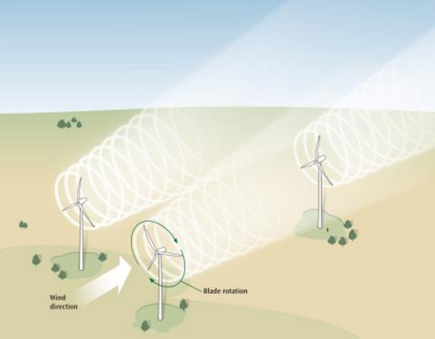
Figure 1: Figure captions should always be positioned bellow the figure and set to 10 points font size, centered and inset 2,0 cm from the right and left margins
Authors are responsible for obtaining permission to reproduce copyrighted material from other sources. As an author, you are required to secure permission if you want to reproduce any figure, table or extract from the text of another source.

Formulas
Formulas should be placed in a separate line, centered and must be cited within the text with proper link (Formula 1). Displayed expressions must be numbered in the caption, which should be set in the same line as the formula, enclosed in parentheses and right margined.
$$a^{2}+y^{2}=z$$ | (1)

Citations
When citing authors should use the author-date system, which means including in the text and between curved brackets, the last name of the authors and the date – example (Smith 2005). The complete reference should be listed at the end of the document using the Chicago Manual of Style. Instructions and examples of references can be found at http://www.chicagomanualofstyle.org. Authors can use tools like EndNote or Mendeley to support this process.

Conclusions
Lorem ipsum dolor sit amet, consectetur adipiscing elit. Nam ut tincidunt lorem. Vivamus vehicula tincidunt ipsum, at faucibus velit ornare euismod. Aenean fermentum neque eget lacinia vehicula. In et eros fringilla, euismod lorem eu, tempor lectus. Fusce consequat, (…)

References
Cardoso, Henrique Daniel de Avelar Lopes and Eugénio da Costa Oliveira. 2005. "Virtual enterprise normative framework within electronic institutions". In Engineering Societies in the Agents World V, 14-32. Heidelberg: Springer.
Stachowiak, Gwidon W. and Andrew W. Batchelor. 2014. "Computational Hydrodynamics". Em Engineering Tribology (4th Edition). Accessed 14 July, 2014. http://app.knovel.com/hotlink/toc/id:kpETE00005/engineering-tribology/engineering-tribology.
Gunerhan, H., A. Hepbasli and U. Giresunlu. 2009. "Environmental impacts from the solar energy systems". Energy Sources, Part A: Recovery, Utilization and Environmental Effects 31 (2):131-138. Accessed 28 August, 2014. DOI: 10.1080/15567030701512733.

Acknowledgments
This section is conventionally used to thank persons and granting agencies for their help and support. in the revision version of the manuscript this section must be omitted: it gives too much information about the authors to the reviewers.

