The title of the contribution (Title EN)
Name - Institution, City, Country, e-mail: (insert affiliate institution address) (Author’s surname and name, in this order, Institution, City, Country, email)
Name - Institution, City, Country, e-mail: (insert affiliate institution address) (Author’s surname and name, in this order, Institution, City, Country, email)
Abstract: A concise and factual abstract of about 150-200 words is required. The abstract should briefly state the purpose of the research, the principal results and major conclusions. An abstract is often presented separately from the article, so it must be able to stand alone. For this reason, avoid any reference, but if essential, then cite the author(s) and year(s). The abstract will be written in regular (size 10) TNR, 1.2 cm paragraph left-right, (ABSTRACT in english)
Keywords: 4-5 representative words for paper (Keywords in English)
1. Introduction (Chapter)
This template is dedicated for Full Paper written in English.
The title “Introduction” will be numbered, written in small capitals (size 12), bolded, aligned left.
In the introduction of the article, the state of the art of the domain will be mentioned (by citing the corresponding references) and the objectives of the paper will be stated.
The contribution will consist of maximum 12 pages for Full Paper (even number is preferable, size A4, all margins at 2.5 cm) the font used being TNR, size 12, the paragraphs being separated from one another with one line of size 6. (Normal text). Save your file both in pdf format and in docx format.
Authors are encouraged to submit extended abstract and full paper simultaneously. Please check template for extended abstracts in the website.
2. Paper content (the title of the first chapter) (Chapter)
The titles of the chapters will be numbered, written in small capitals (size 12), bolded, aligned left.
The International System of Units will be used. Papers are to be submitted in English language.
2.1. Subchapter Subchapter (1.1)
2.1.1. Subsubchapter Subsubchapter (1.2.1)
3. Paper content (the title of the second chapter) (Chapter)
Equations. Equations are to be numbered consequently, numbers to be indented to the right, and typeset with the equations-editor: Settings – size: 12, 10, 7, 18, 12, style: italic variables, LG Greek italic.
$m⋅\ddot{y}(t)+c⋅\dot{y}(t)+k⋅y(t)=-m⋅a(t)$ (Equations) (1)

Tables. Tables are to be typeset in TNR size 10. The number and the title of the table is to be centred and its numeration written in italics (size 10). The table is centred. Use the table function, not spreadsheets, to make tables.

Table 1. (Number of the Table) Melting points and basic analysis (Table Title)
Compounds | Mp(⁰C) | Chemical formula | N (%)
 |  |  | Calculated | Resulted
3A | 178 | C₂₉H₃₄N₂O | 6,57 | 3A
3B | 264 | C₂₉H₃₃N₃O₃ | 8,92 | 3B
3C | 232 | C₂₉H₃₂N₄O₅ | 10,85 | 3C
5A | 185 | C₂₉H₃₄N₂O | 6,56 | 5A
5B | 242 | C₂₉H₃₃N₃O₃ | 8,92 | 5B

Figures. Figures are to be placed centred, if they are big and complex enough. If not, they can be put on two columns or wrapped in the text, towards the exterior of the page (right for an even page and left for an uneven page). The legend is to be centred under the figure, in TNR size 10.
Photographs, drawings, or paintings should have a minimum resolution of 300 dpi (600 dpi for colour figures). Please make sure that artwork files are in an acceptable format (TIFF (or JPEG), EPS (or PDF), or MS Office files) and with the correct resolution. Do not include titles or captions within your illustrations. Fonts in the figures must be embedded.
Under no circumstance is it acceptable to change the orientation of any page to “Landscape” to accommodate an illustration or exhibit – these pages will not output properly in the proceedings volume.
All figures and tables must be referred to and described in the text.

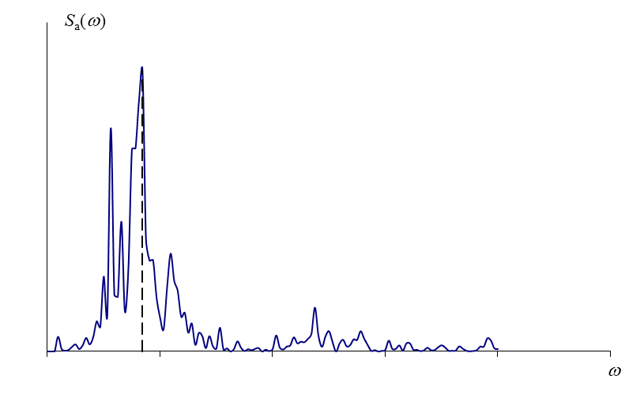
Figure 1. The legend is centred (size 10) (Figure)
4. Conclusions (Chapter)
The contribution will conclude with the main results and conclusions obtained by the author(s).
Acknowledgements (Chapter)
If necessary.
References (Chapter)
The references must be cited in the text by name and year in parentheses. For example: [1], [2-4].
The list of references should only include works that are cited in the text and that have been published or accepted for publication. Reference list entries should be alphabetized by the last names of the first author of each publication.
[1] Furtado, H. Rodrigues, A. Arêde, H. Varum, H (2016) Experimental evaluation of out-of-plane capacity of masonry infill walls, Engineering Structures, Volume 111, March 15, 2016, Pages 48-63. https://doi.org/10.1016/j.engstruct.2015.12.013
[2] M. De Risi, A. Furtado, H. Rodrigues, J. Melo, G. Verderame, A. Arêde, H. Varum, G. Manfredi (2022) “Influence of textile reinforced mortars strengthening on the in-plane/out-of-plane response of masonry infill walls in RC frames2. Engineering Structures, 254

